KIET Group of Institutions, Ghaziabad

**COMPUTER SCIENCE AND INFORMATION TECHNOLOGY**

**PROJECT BASED LEARNING**

**on**

**HOTEL MANAGEMENT SYSTEM**

**SUBJECT: DATA STRUCTURES USING C LAB**

|  |  |
| --- | --- |
| **(KCS-301)** |  |
| **Submitted By:** |
| **SAURABH TRIPATHI** | **- 2100290110148** |
| **SATWIK GAUTAM** | **- 2100290110145** |

# ACKNOWLEDGEMENT

I’ve got this golden opportunity to express my kind gratitude and sincere thanks to my lab faculty **“Mr. Vinay Kumar”**, Computer Science and Information Technology Department, **KIET GROUP OF INSTITUTIONS** for their kind support and necessary counselling in the preparation of this project report. I’m also indebted to every person responsible for the making up of this project directly or indirectly.

I must also acknowledge or deep debt of gratitude each one of my colleagues who led this project come out in the way it is. It’s my hard work and untiring sincere efforts and cooperation to bring out the project work. Last but not the least, I would like to thank my parents for their sound counselling and cheerful support. They have always inspired us and kept our spirit up.

# ABSTRACT

The system aims at the maintenance and management of the different Hotels that are available in the different parts of the world. It mainly takes care of the Hotel management at the core area of the database. The system provides the information regarding the different Hotels that are available and their status specific to availability. The guests can visit the site and register themselves with the required information that is expected by the system. Each registered guest can raise a request for the unit bookings. The Guests are scheduled with the information of the availability of the units for they have requested the time.

# INDEX

|  |  |  |
| --- | --- | --- |
| S.NO. | TOPIC | PAGE NO. |
| 1. | Introduction | 5 |
| 2. | Requirement Analysis | 6 |
| 3. | Design | 7 |
| 4. | Coding Implementation | 8-15 |
| 5. | Result/Output | 16-17 |
| 6. | Reference | 18 |

**INTRODUCTION**

**Problem Statement:** To make a Hotel Management System. To use to array data structures to achieve the aim.

**Purpose:** The primary features that make up the main menu of this Hotel program include adding new records, listing them, altering and updating them, searching for stored contacts, and deleting hotel data.

# REQUIREMENT ANALYSIS

**Functional Requirements:** No additional functional requirements required.

**Dependencies**: The program is made in C language so it will run on a code blocks compiler.

**Hardware and software requirements**: The Program will run on any working computer using any C compiler.

# DESIGN

**Methodology:** To use data structure to store Hotel client data and display data.

**Flowchart:**

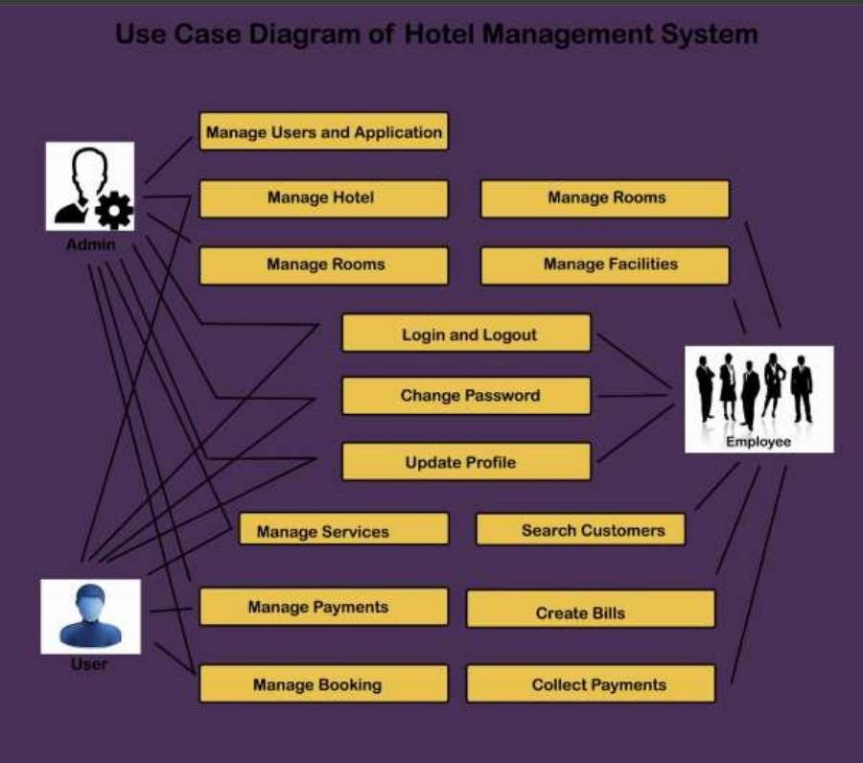

# CODING IMPLEMENTATION:

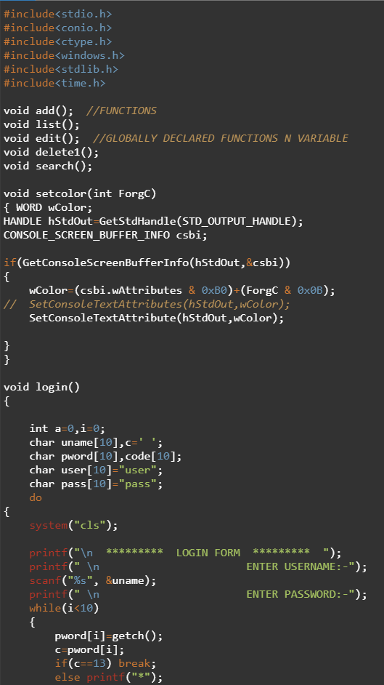

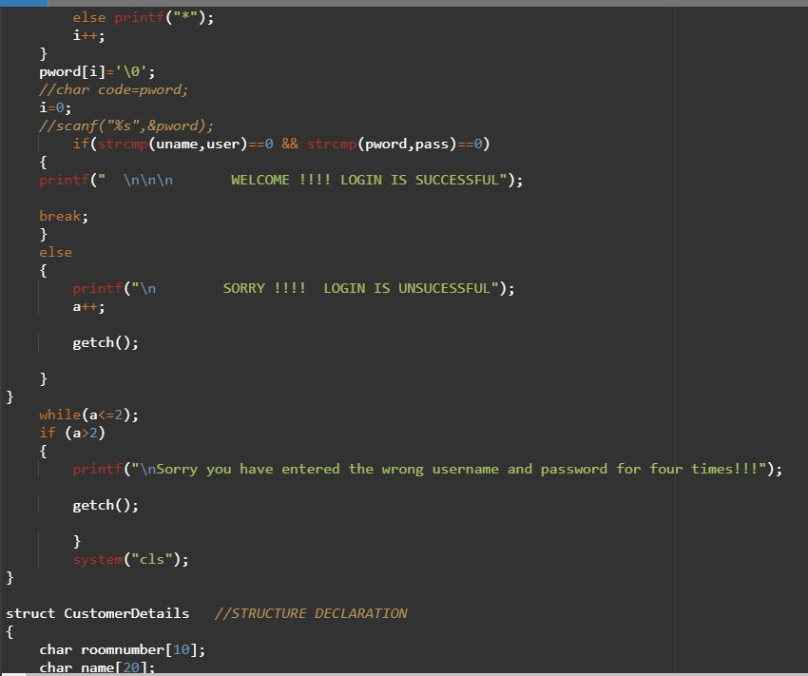

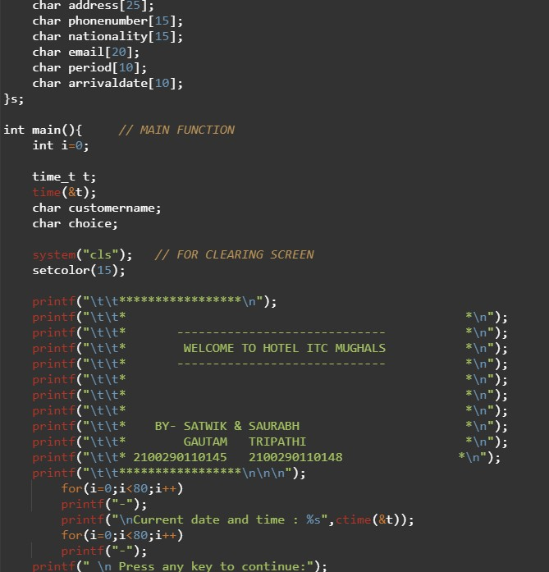

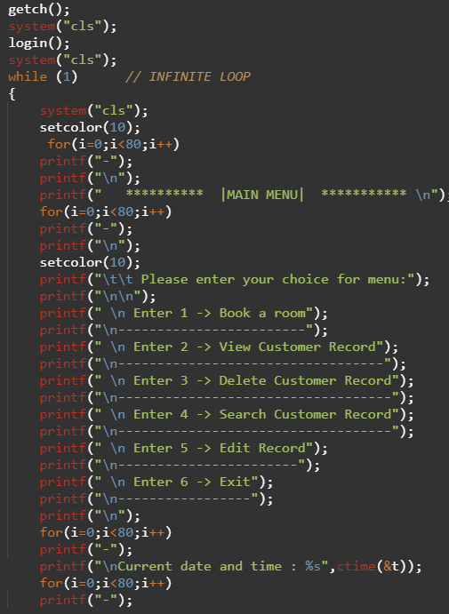

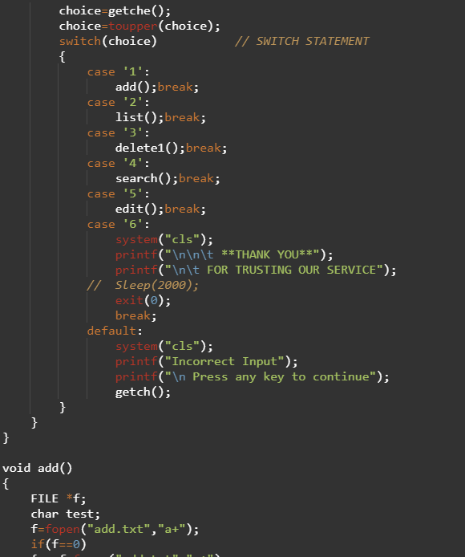

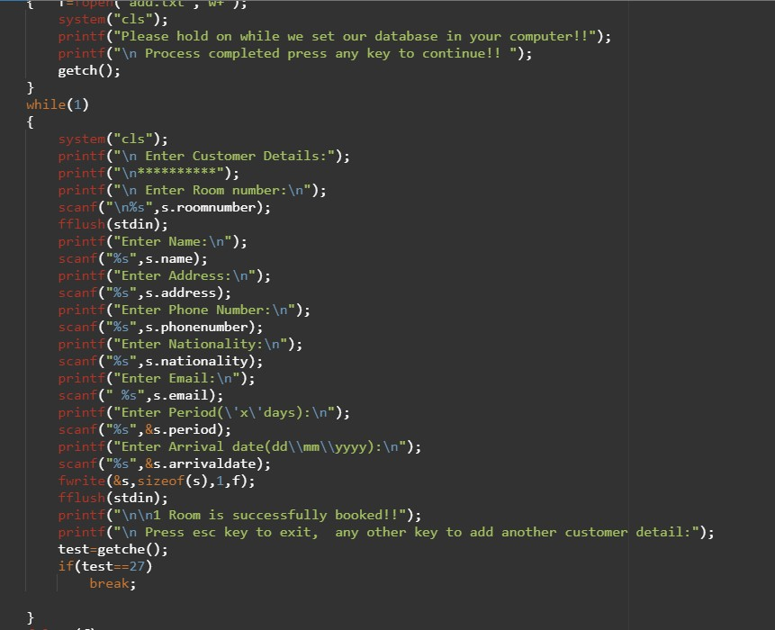

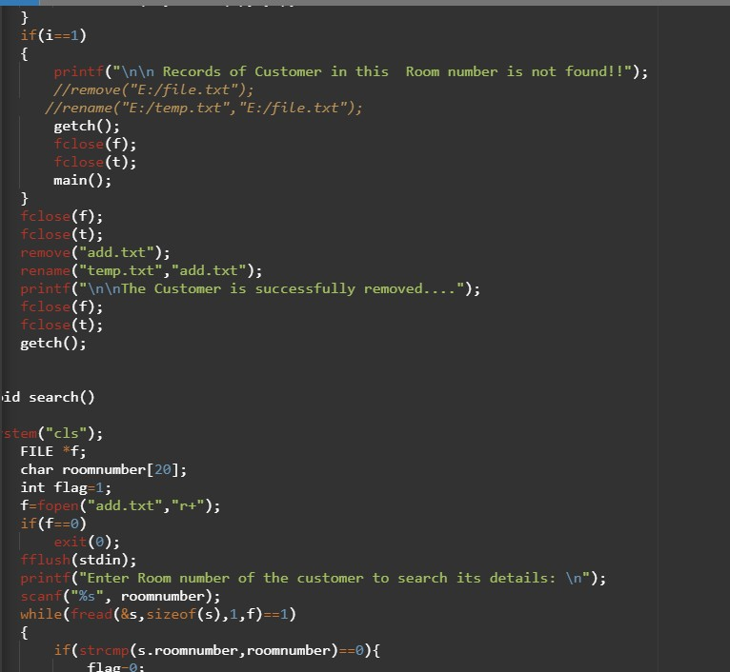

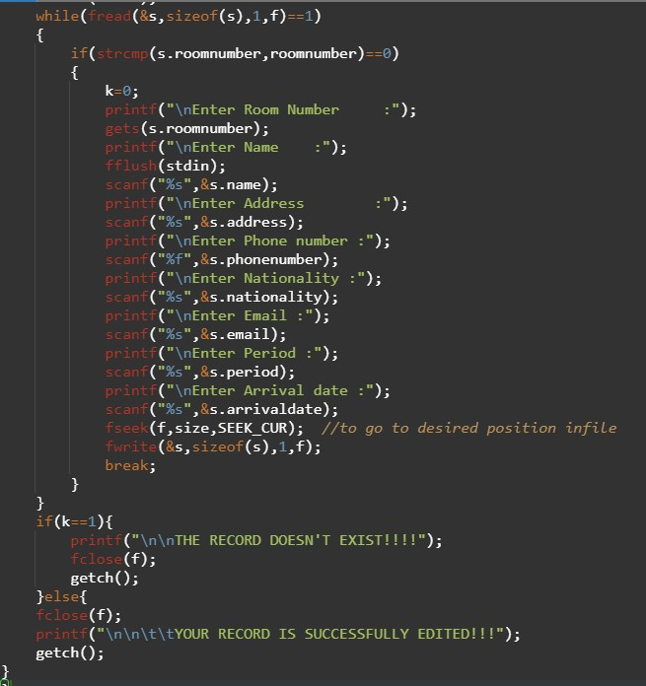

**RESULT / OUTPUT**

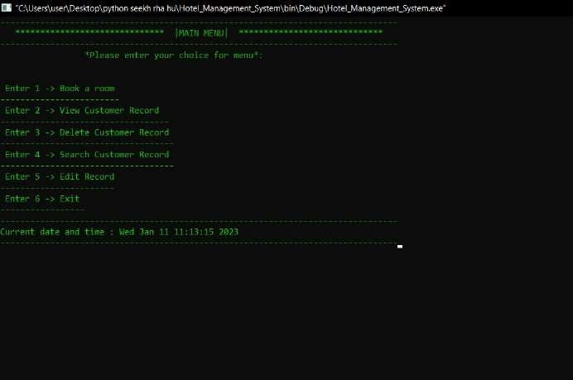

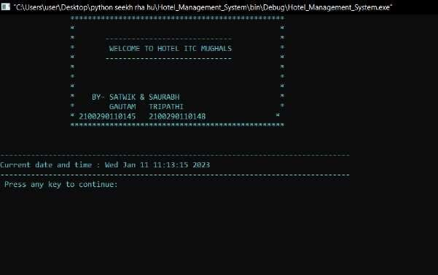

# REFERENCES:

1) <https://youtube.com/watch?v=2-MGoMgBKOQ&si=EnSIkaIECMiOmarE>

2) <https://code-projects.org/hotel-management-system-c-programming-source-code/>